Sprint -4

|  |  |
| --- | --- |
| **Date** | **10 November 2022** |
| **Team ID** | **PNT2022TMID53703** |
| **Project name** | **IOT Based Smart Crop Protection System for Agriculture** |
| **Mark** | **20 Marks** |

Node JS installation:

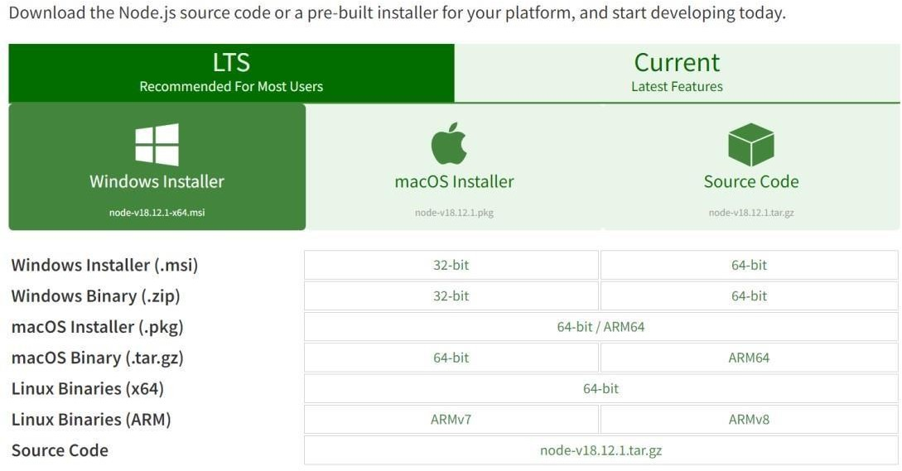

Configure command prompt for error check .open node-red from the generated link:

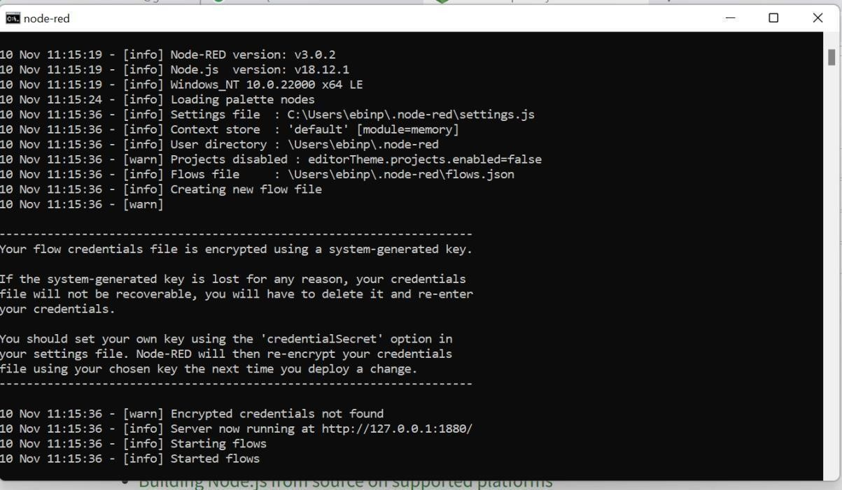

Connection IBM IOT in debug 1 and deploy:

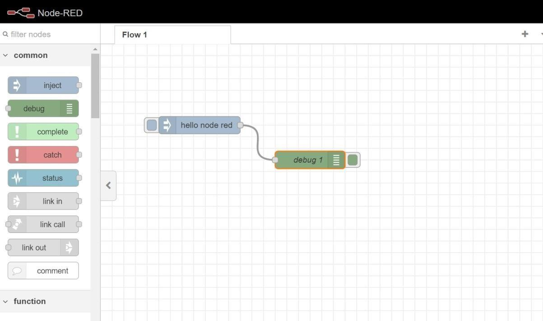

Output:

